МИНИСТЕРСТВО НАУКИ И ВЫСШЕГО ОБРАЗОВАНИЯ РОССИЙСКОЙ ФЕДЕРАЦИИ
ФЕДЕРАЛЬНОЕ ГОСУДАРСТВЕННОЕ БЮДЖЕТНОЕ ОБРАЗОВАТЕЛЬНОЕ УЧРЕЖДЕНИЕ ВЫСШЕГО ОБРАЗОВАНИЯ «МОСКОВСКИЙ ГОСУДАРСТВЕННЫЙ УНИВЕРСИТЕТ ТЕХНОЛОГИЙ И УПРАВЛЕНИЯ ИМЕНИ К.Г. РАЗУМОВСКОГО (ПЕРВЫЙ КАЗАЧИЙ УНИВЕРСИТЕТ)»
(ФГБОУ ВО «МГУТУ ИМ. К.Г. РАЗУМОВСКОГО (ПКУ)»)
УНИВЕРСИТЕТСКИЙ КОЛЛЕДЖ ИНФОРМАЦИОННЫХ ТЕХНОЛОГИЙ

Отчёт по
выполнению УП 02 01
по заданию «Павильоны»
Сессия 1

студента группы ПКС-304 специальности 09.02.03 Программирование в компьютерных системах
Швецов Александр Иванович

1.1 СОЗДАНИЕ БАЗЫ ДАННЫХ

1 Диаграмма базы данных

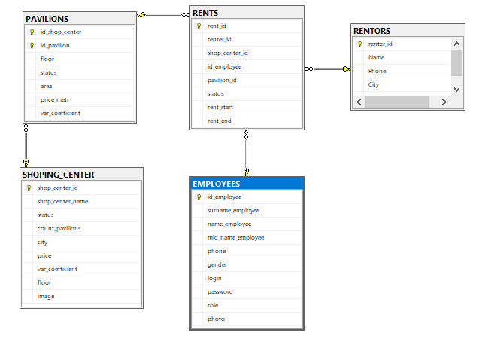

2 Скриншот таблиц
EMPLOYEES (Работники)
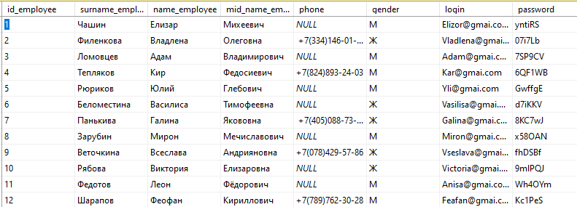

PAVILIONS (Павильоны)
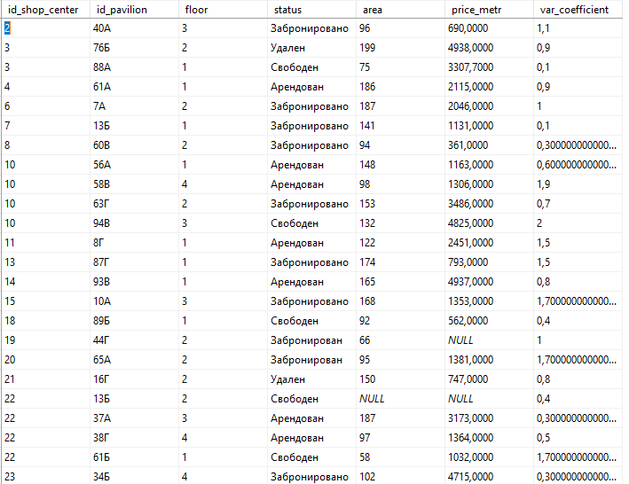

RENTORS (Арендаторы)
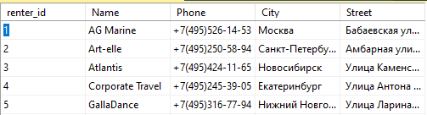

RENTS (Аренда)
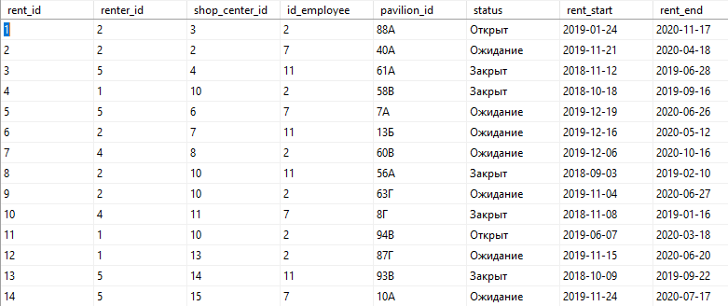

SHOPING_CENTER (Торговый центр)
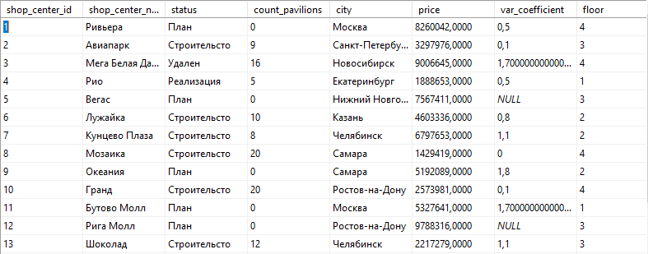
3Вывод количества записей в таблицах

SHOPING_CENTER
SELECT COUNT(shop_center_id) AS Count_Fild
FROM dbo.SHOPING_CENTER
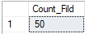
RENTS
SELECT COUNT(rent_id) AS Count_field
FROM dbo.RENTS
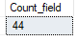
RENTORS
SELECT COUNT(rent_id) AS Count_field
FROM dbo.RENTS
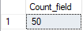
PAVILIONS
SELECT COUNT(id_shop_center) AS Count_field
FROM dbo.PAVILIONS
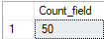
EMPLOYEES
SELECT COUNT(id_employee) AS Count_field
FROM dbo.EMPLOYEES
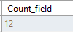
ЗАГРУЗКА ФОТОГРАФИЙ В БАЗУ ДАННЫХ

Код приложения
using System;
using System.Collections.Generic;
using System.Data.SqlClient;
using System.IO;
using System.Linq;
using System.Text;
using System.Threading.Tasks;

namespace imagedownload
{
class Program
{
static void Main(string[] args)
{
SqlConnectionStringBuilder builder = new SqlConnectionStringBuilder
{
DataSource = @"PC\SQLEXPRESS",
InitialCatalog = "PAVILIONS",
IntegratedSecurity = true
};
SqlConnection connection = new SqlConnection(builder.ConnectionString);
DirectoryInfo d = new DirectoryInfo(@"C:\Users\иван\Desktop\УП\Технологии защиты базы данных\2 УП\Image ТЦ ");
FileInfo[] files = d.GetFiles("*.jpg");
SqlCommand cmd;
connection.Open();
for (int i = 0; i < files.Length; i++)
{
cmd = new SqlCommand("UPDATE SHOPING_CENTERS SET image = @image where shop_center_name = @name", connection);
cmd.Parameters.AddWithValue("@image", File.ReadAllBytes(files[i].FullName));
cmd.Parameters.AddWithValue("@name", files[i].Name.Remove(files[i].Name.Length - 4, 4));
cmd.ExecuteNonQuery();
}
connection.Close();
}
}
}
1.2 СОЗДАНИЕ ПРИЛОЖЕНИЯ

1.3 АВТОРИЗАЦИЯ
Скриншоты
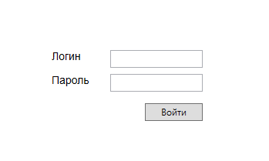
Код приложения
using System;
using System.Collections.Generic;
using System.Data.SqlClient;
using System.Linq;
using System.Text;
using System.Threading.Tasks;
using System.Windows;
using System.Windows.Controls;
using System.Windows.Data;
using System.Windows.Documents;
using System.Windows.Input;
using System.Windows.Media;
using System.Windows.Media.Imaging;
using System.Windows.Navigation;
using System.Windows.Shapes;

namespace PAVILIONS
{
/// <summary>
/// Логика взаимодействия для AvthorizationPage.xaml
/// </summary>
public partial class AvthorizationPage : Page
{
public class Captcha
{
public byte[] ImageCaptcha { get; set; }
}
public int RandomNumberCaptcha { get; set; }
public int CountClickButton { get; set; }
public AvthorizationPage()
{
InitializeComponent();
CountClickButton = 0;
}
int RandomCaptcha(int Min_count, int Max_count)
{
var random = new Random();
Manager.connection.Open();
RandomNumberCaptcha = random.Next(Min_count, Max_count);
string sqlExpression = "SELECT number_captcha, captcha, captcha_image " +
"FROM dbo.CAPTCHA " +
"WHERE(number_captcha = @NumberCaptcha)";
SqlCommand command = new SqlCommand(sqlExpression, Manager.connection);
SqlParameter Number_captcha = new SqlParameter("@NumberCaptcha", RandomNumberCaptcha);
command.Parameters.Add(Number_captcha);
SqlDataReader Reader = command.ExecuteReader();
if (Reader.Read())
{
Captcha captcha = new Captcha();
captcha.ImageCaptcha = Reader[2] as byte[];
List<Captcha> captchas = new List<Captcha>();
captchas.Add(captcha);
CaptchaImage.DataContext = captchas;
}
Reader.Close();
Manager.connection.Close();
return 0;
}
private void Log_in_Button_Click(object sender, RoutedEventArgs e)
{
string Password = Password = PasswordBox.Password;
string Login = LoginTextBox.Text.Trim();
int Min_count = 0;
int Max_count = 0;
int CaptchaError = 0;
try
{
if (CountClickButton >= 3)
{
Manager.connection.Open();
string sqlExpressionCaptcha = "SELECT * FROM CAPTCHA WHERE(number_captcha = @NumberCaptcha)" + // провверка правильности каптчи
" AND captcha COLLATE SQL_Latin1_General_CP1_CS_AS = @ContentCaptcha";
SqlCommand commandCaptcha = new SqlCommand(sqlExpressionCaptcha, Manager.connection);
SqlParameter Login_param_Captcha = new SqlParameter("@NumberCaptcha", RandomNumberCaptcha);
commandCaptcha.Parameters.Add(Login_param_Captcha);
SqlParameter Password_param_Captcha = new SqlParameter("@ContentCaptcha", CaptchaTextBox.Text);
commandCaptcha.Parameters.Add(Password_param_Captcha);
SqlDataReader ReaderCaptcha = commandCaptcha.ExecuteReader();
if (ReaderCaptcha.HasRows)
{
CaptchaError = 0;
MessageBox.Show("ok");
}
else
{
MessageBox.Show("Капча не совпадает");
CaptchaError = -1;
}
ReaderCaptcha.Close();
if (CaptchaError == 0)
{
sqlExpressionCaptcha = "SELECT * FROM EMPLOYEES WHERE([login] COLLATE SQL_Latin1_General_CP1_CS_AS = @Login)" + // проверка логина и пороля
" AND [password] COLLATE Cyrillic_General_CS_AS = @Password";
commandCaptcha = new SqlCommand(sqlExpressionCaptcha, Manager.connection);
Login_param_Captcha = new SqlParameter("@Login", Login);
commandCaptcha.Parameters.Add(Login_param_Captcha);
Password_param_Captcha = new SqlParameter("@Password", Password);
commandCaptcha.Parameters.Add(Password_param_Captcha);
ReaderCaptcha = commandCaptcha.ExecuteReader();
if (ReaderCaptcha.HasRows)
{
Manager.connection.Close();
Manager.FrameMainWindows.Navigate(new EmployeesMainPage(Login));
CountClickButton = 0;
}
else
{
RandomCaptcha(Min_count, Max_count);
}
ReaderCaptcha.Close();
Manager.connection.Close();
}
}
else
{
Manager.connection.Open();
string sqlExpression = "SELECT * FROM EMPLOYEES WHERE([login] COLLATE SQL_Latin1_General_CP1_CS_AS = @Login)" + // проверка логина и пороля
" AND [password] COLLATE Cyrillic_General_CS_AS = @Password";
SqlCommand command = new SqlCommand(sqlExpression, Manager.connection);
SqlParameter Login_param = new SqlParameter("@Login", Login);
command.Parameters.Add(Login_param);
SqlParameter Password_param = new SqlParameter("@Password", Password);
command.Parameters.Add(Password_param);
SqlDataReader Reader = command.ExecuteReader();
if (Reader.HasRows)
{
Manager.connection.Close();
Manager.FrameMainWindows.Navigate(new EmployeesMainPage(Login));
Reader.Close();
}
else
{
Reader.Close();
CountClickButton++;
if (CountClickButton >= 3)
{
CaptchaImage.Visibility = Visibility.Visible;
CaptchaTextBox.Visibility = Visibility.Visible; // много раз ошибся формируем каптчу
sqlExpression = "SELECT TOP (100) PERCENT number_captcha AS Expr1, captcha, captcha_image " +
"FROM dbo.CAPTCHA " +
"ORDER BY Expr1";
command = new SqlCommand(sqlExpression, Manager.connection);
Reader = command.ExecuteReader();
if (Reader.Read())
{
Min_count = Convert.ToInt32(Reader[0].ToString());
Reader.Close();
}

sqlExpression = "SELECT TOP (100) PERCENT number_captcha AS Expr1, captcha, captcha_image " +
"FROM dbo.CAPTCHA " +
"ORDER BY Expr1 DESC";
command = new SqlCommand(sqlExpression, Manager.connection);
Reader = command.ExecuteReader();
if (Reader.Read())
{
Max_count = Convert.ToInt32(Reader[0].ToString());
Reader.Close();
}
Reader.Close();
RandomCaptcha(Min_count, Max_count);
//
}
Reader.Close();
}
Manager.connection.Close();
}
}

catch (SqlException error)
{
MessageBox.Show(error.Message);
}
}
}
}

1.4 ИНТЕРФЕЙС «МЕНЕДЖЕРА C»
СПИСОК ТЦ
Скриншот
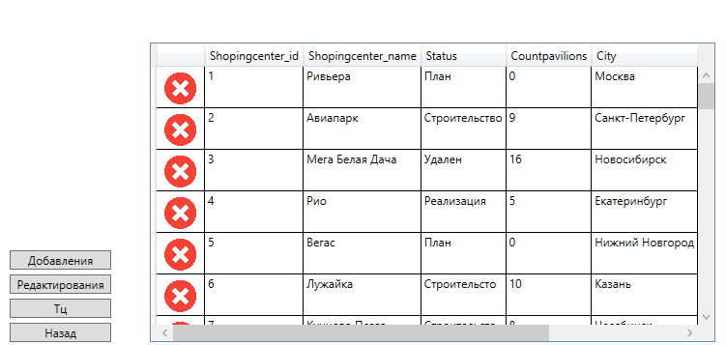
Код приложения на XAML, C#
using System;
using System.Collections.Generic;
using System.Linq;
using System.Text;
using System.Threading.Tasks;
using System.Windows;
using System.Windows.Controls;
using System.Windows.Data;
using System.Windows.Documents;
using System.Windows.Input;
using System.Windows.Media;
using System.Windows.Media.Imaging;
using System.Windows.Navigation;
using System.Windows.Shapes;
using System.Data.SqlClient;

namespace PAVILIONS
{
/// <summary>
/// Логика взаимодействия для ListTCPage.xaml
/// </summary>
public partial class ListTCPage : Page
{
public class Shoping_Center
{
public string Shoping_center_id { get; set; }
public string Shoping_center_name { get; set; }
public string Status { get; set; }
public string Count_pavilions { get; set; }
public string City { get; set; }
public string Price { get; set; }
public string Var_coefficient { get; set; }
public string Floor { get; set; }
}
public string Login { get; set; }
public ListTCPage(string Login_get)
{
InitializeComponent();
Login = Login_get;
}
public int Shoping_center_show()
{
Manager.connection.Open();
string Sqlexpression = "select * from SHOPING_CENTER";
SqlCommand command = new SqlCommand(Sqlexpression, Manager.connection);
SqlDataReader reader = command.ExecuteReader();
List<Shoping_Center> shoping_Centers = new List<Shoping_Center>();
while (reader.Read())
{
Shoping_Center SC = new Shoping_Center();
SC.Shoping_center_id = reader[0].ToString();
SC.Shoping_center_name = reader[1].ToString();
SC.Status = reader[2].ToString();
SC.Count_pavilions = reader[3].ToString();
SC.City = reader[4].ToString();
SC.Price = reader[5].ToString();
SC.Var_coefficient = reader[6].ToString();
SC.Floor = reader[7].ToString();
shoping_Centers.Add(SC);
}
ListTCDataGrid.ItemsSource = shoping_Centers;
reader.Close();
Manager.connection.Close();
return 0;
}

private void Exit_Button_Click(object sender, RoutedEventArgs e)
{
Manager.FrameMainWindows.Navigate(new EmployeesMainPage(Login));
}

private void Mall_Button_Click(object sender, RoutedEventArgs e)
{
Shoping_center_show();
}
private void Delete_Button_Click(object sender, RoutedEventArgs e)
{
string Code_book = "";
Shoping_Center shoping_Center = (Shoping_Center)ListTCDataGrid.SelectedItem;
if (shoping_Center == null)
{
MessageBox.Show("Выберите товар!");
}
else
{
try
{
Manager.connection.Open();
string sqlExpression = "delete FROM SHOPING_CENTER where shop_center_id = @Shoping_center_id";
SqlCommand command = new SqlCommand(sqlExpression, Manager.connection);
SqlParameter Code_book_param = new SqlParameter("@Shoping_center_id", shoping_Center.Shoping_center_id);
command.Parameters.Add(Code_book_param);
SqlDataReader Reader = command.ExecuteReader();
Reader.Close();
Manager.connection.Close();
Shoping_center_show();
}
catch (SqlException error)
{
MessageBox.Show((error.Number).ToString() + " " + error.Message);
}
}
}
private void InformationTC(object sender, MouseButtonEventArgs e)
{
Shoping_Center shoping_Center = (Shoping_Center)ListTCDataGrid.SelectedItem;
Manager.FrameMainWindows.Navigate(new InformationTCPage(shoping_Center.Shoping_center_id));
}

private void Edit_Pavillion_Button_Click(object sender, RoutedEventArgs e)
{
Shoping_Center shoping_Center = (Shoping_Center)ListTCDataGrid.SelectedItem;
Manager.FrameMainWindows.Navigate(new EditShopCenterPage(shoping_Center.Shoping_center_name, shoping_Center.Status,
shoping_Center.Count_pavilions, shoping_Center.City, shoping_Center.Price, shoping_Center.Var_coefficient, shoping_Center.Floor));
}

private void Add_Pavillion_Button_Click(object sender, RoutedEventArgs e)
{
Manager.FrameMainWindows.Navigate(new AddPavilionPage());
}
}
}
1.5 ИНТЕРФЕЙС «МЕНЕДЖЕРА C»
СПИСОК ПАВИЛЬОНОВ
Скриншот
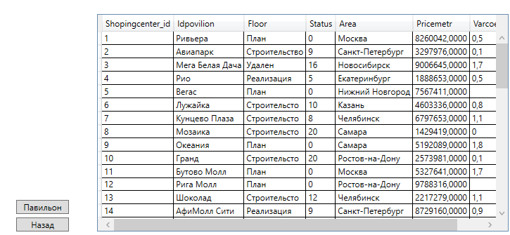
Код приложения на XAML, C#
private void Update_Button_Click(object sender, RoutedEventArgs e)
{
Manager.connection.Close();
Manager.connection.Open();
List<Pavilions> pavilions = new List<Pavilions>();
string Sqlexpression = "SELECT DISTINCT dbo.PAVILIONS.* " +
" FROM dbo.PAVILIONS INNER JOIN dbo.SHOPING_CENTER ON dbo.PAVILIONS.id_shop_center = dbo.SHOPING_CENTER.shop_center_id " +
"WHERE(dbo.SHOPING_CENTER.shop_center_id = @shop_center_id and PAVILIONS.[status] = 'Свободен')";
SqlCommand command = new SqlCommand(Sqlexpression, Manager.connection);
SqlParameter sqlParameter = new SqlParameter("@shop_center_id", Id_shop_center);
command.Parameters.Add(sqlParameter);
SqlDataReader reader = command.ExecuteReader();
while (reader.Read())
{
Pavilions pavilion = new Pavilions();
pavilion.id_shop_center = reader[0].ToString();
pavilion.id_pavilions = reader[1].ToString();
pavilion.floor = reader[2].ToString();
pavilion.status = reader[3].ToString();
pavilion.area = reader[4].ToString();
pavilion.price_metr = reader[5].ToString();
pavilion.var_coefficient = reader[6].ToString();
pavilions.Add(pavilion);
}
PavilionsDataGrid.ItemsSource = pavilions;
reader.Close();
Manager.connection.Close();
}
1.6 ИНТЕРФЕЙС «МЕНЕДЖЕРА C»
ИНТЕРФЕЙС ТЦ
Скриншот
Редактирования:
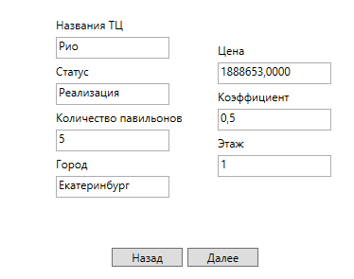
Код приложения на XAML, C#
using System;
using System.Collections.Generic;
using System.Data.SqlClient;
using System.Linq;
using System.Text;
using System.Threading.Tasks;
using System.Windows;
using System.Windows.Controls;
using System.Windows.Data;
using System.Windows.Documents;
using System.Windows.Input;
using System.Windows.Media;
using System.Windows.Media.Imaging;
using System.Windows.Navigation;
using System.Windows.Shapes;

namespace PAVILIONS
{
/// <summary>
/// Логика взаимодействия для EditShopCenterPage.xaml
/// </summary>
public partial class EditShopCenterPage : Page
{
public string Shop_Center_Name_Old { get; set; }
public string Status_Old { get; set; }
public string Count_Pavilions_Old { get; set; }
public string City_Old { get; set; }
public string Price_Old { get; set; }
public string Coefficient_Old { get; set; }
public string Floor_Old { get; set; }

public EditShopCenterPage(string shoping_center_name, string status, string count_pavilions, string city, string price,
string var_coefficient, string floor)
{
InitializeComponent();
Manager.connection.Close();
Shoping_center_name.Text = shoping_center_name;
Status.Text = status;
Count_pavilion.Text = count_pavilions;
City.Text = city;
Price.Text = price;
Coefficient.Text = var_coefficient;
Floor.Text = floor;
Shop_Center_Name_Old = Shoping_center_name.Text.Trim();
Status_Old = Status.Text.Trim();
Count_Pavilions_Old = Count_pavilion.Text.Trim();
City_Old = City.Text.Trim();
Price_Old = Price.Text.Trim();
Coefficient_Old = Coefficient.Text.Trim();
Floor_Old = Floor.Text.Trim();
}

private void Go_Back_Button_Click(object sender, RoutedEventArgs e)
{
Manager.FrameMainWindows.GoBack();
}

private void Next_Button_Click(object sender, RoutedEventArgs e)
{
try
{
string Shoping_center_name_new = Shoping_center_name.Text;
string Status_new = Status.Text;
string Count_pavilion_new = Count_pavilion.Text;
string City_new = City.Text;
string Price_new = Price.Text;
string Coefficient_new = Coefficient.Text;
string Floor_new = Floor.Text;
Manager.connection.Close();
Manager.connection.Open();
string sqlExpression = "Update SHOPING_CENTER set shop_center_name = @Shoping_center_name_new, status = @Status_new, count_pavilions = @Count_pavilion_new," +
" city = @City_new, price = @Price_new, var_coefficient = @Coefficient_new, floor = @Floor_new where" +
" shop_center_name = @Shop_Center_Name_Old AND status = @Status AND count_pavilions = @Count_pavilion AND city = @City AND price = @Price" +
" AND var_coefficient = @Coefficient AND floor = @Floor";
SqlCommand command = new SqlCommand(sqlExpression, Manager.connection);
SqlParameter New_Login_param = new SqlParameter("@Shoping_center_name_new", Shoping_center_name_new);
command.Parameters.Add(New_Login_param);
SqlParameter Login_param = new SqlParameter("@Shop_Center_Name_Old", Shop_Center_Name_Old);
command.Parameters.Add(Login_param);
SqlParameter Surname_param = new SqlParameter("@Surname", Status_Old);
command.Parameters.Add(Surname_param);
SqlParameter New_Surname_param = new SqlParameter("@New_Surname", Status_new);
command.Parameters.Add(New_Surname_param);
SqlParameter Name_buyer_param = new SqlParameter("@Count_pavilion", Count_Pavilions_Old);
command.Parameters.Add(Name_buyer_param);
SqlParameter New_Name_buyer_param = new SqlParameter("@Count_pavilion_new", Count_pavilion_new);
command.Parameters.Add(New_Name_buyer_param);
SqlParameter Email_param = new SqlParameter("@City", City_Old);
command.Parameters.Add(Email_param);
SqlParameter New_Email_param = new SqlParameter("@City_new", City_new);
command.Parameters.Add(New_Email_param);
SqlParameter Number_card_param = new SqlParameter("@Price", Price_Old);
command.Parameters.Add(Number_card_param);
SqlParameter New_Number_card_param = new SqlParameter("@Price_new", Price_new);
command.Parameters.Add(New_Number_card_param);
SqlParameter User_password_param = new SqlParameter("@Coefficient",Convert.ToDouble(Coefficient_Old));
command.Parameters.Add(User_password_param);
SqlParameter New_User_password_param = new SqlParameter("@Coefficient_new",Convert.ToDouble(Coefficient_new));
command.Parameters.Add(New_User_password_param);
SqlParameter Floor_new_param = new SqlParameter("@Floor", Floor_Old);
command.Parameters.Add(Floor_new_param);
SqlParameter Floor_old_param = new SqlParameter("@Floor_new", Floor_new);
command.Parameters.Add(Floor_old_param);
SqlParameter Status_new_param = new SqlParameter("@Status", Status_Old);
command.Parameters.Add(Floor_new_param);
SqlParameter Status_old_param = new SqlParameter("@Status_new", Status_new);
command.Parameters.Add(Floor_old_param);
command.ExecuteNonQuery();
MessageBox.Show("Данные отредактированы!");
Manager.FrameMainWindows.GoBack();
Manager.connection.Close();
}
catch (SqlException er)
{
MessageBox.Show((er.Number).ToString() + " " + er.Message);
}

}
}
}
Добавления:
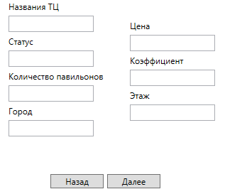
Код приложения на XAML, C#
using System;
using System.Collections.Generic;
using System.Data.SqlClient;
using System.IO;
using System.Linq;
using System.Text;
using System.Threading.Tasks;
using System.Windows;
using System.Windows.Controls;
using System.Windows.Data;
using System.Windows.Documents;
using System.Windows.Input;
using System.Windows.Media;
using System.Windows.Media.Imaging;
using System.Windows.Navigation;
using System.Windows.Shapes;

namespace PAVILIONS
{
/// <summary>
/// Логика взаимодействия для AddPavilionPage.xaml
/// </summary>
public partial class AddPavilionPage : Page
{
public AddPavilionPage()
{
InitializeComponent();
}
private void Go_Back_Button_Click(object sender, RoutedEventArgs e)
{
Manager.FrameMainWindows.GoBack();
}

private void Next_Button_Click(object sender, RoutedEventArgs e)
{
try
{
int shop_center_id = 0;
Manager.connection.Open();
string Sqlexpression = "SELECT MAX(shop_center_id) AS Expr1 FROM dbo.SHOPING_CENTER";
SqlCommand command = new SqlCommand(Sqlexpression, Manager.connection);
SqlDataReader reader = command.ExecuteReader();
if (reader.Read())
{
shop_center_id = Convert.ToInt32(reader[0].ToString());
}
reader.Close();
Manager.connection.Close();
FileInfo fInfo = new FileInfo("C:/Users/иван/Desktop/УП/Технологии защиты базы данных/2 УП/Image/foto_not_found.jpg");
long numBytes = fInfo.Length;

byte[] imageData = null;

FileStream fStream = new FileStream("C:/Users/иван/Desktop/УП/Технологии защиты базы данных/2 УП/Image/foto_not_found.jpg", FileMode.Open, FileAccess.Read);
BinaryReader br = new BinaryReader(fStream);
imageData = br.ReadBytes((int)numBytes);
Manager.connection.Close();
Manager.connection.Open();
Sqlexpression = "INSERT INTO SHOPING_CENTER (shop_center_name, count_pavilions," +
" city, price, floor, status, shop_center_id, image, var_coefficient) " +
"VALUES (@Shoping_center_name_new, @Count_pavilion_new," +
" @City_new, @Price_new, @Floor_new, @Status_new, @Shop_center_id, @Photos, @var_coefficient)";
command = new SqlCommand(Sqlexpression, Manager.connection);
SqlParameter New_Login_param = new SqlParameter("@Shoping_center_name_new", Shoping_center_name.Text);
command.Parameters.Add(New_Login_param);
SqlParameter New_Name_buyer_param = new SqlParameter("@Count_pavilion_new", Count_pavilion.Text);
command.Parameters.Add(New_Name_buyer_param);
SqlParameter New_Email_param = new SqlParameter("@City_new", City.Text);
command.Parameters.Add(New_Email_param);
SqlParameter New_Number_card_param = new SqlParameter("@Price_new", Price.Text);
command.Parameters.Add(New_Number_card_param);
SqlParameter New_User_password_param = new SqlParameter("@Var_coefficient", Coefficient.Text);
command.Parameters.Add(New_User_password_param);
SqlParameter Floor_old_param = new SqlParameter("@Floor_new", Floor.Text);
command.Parameters.Add(Floor_old_param);
SqlParameter Status_old_param = new SqlParameter("@Status_new", Status.Text);
command.Parameters.Add(Status_old_param);
SqlParameter CodeBookParam = new SqlParameter("@Shop_center_id", shop_center_id + 1);
command.Parameters.Add(CodeBookParam);
SqlParameter PhotosParam = new SqlParameter("@Photos", imageData);
command.Parameters.Add(PhotosParam);
command.ExecuteNonQuery();
MessageBox.Show("Данные добавленны!");
Manager.FrameMainWindows.GoBack();
Manager.connection.Close();
}
catch (SqlException er)
{
MessageBox.Show((er.Number).ToString() + " " + er.Message);
}

}
}
}
Удаления:
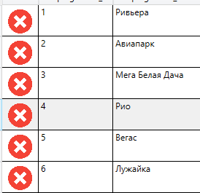
Код приложения на XAML, C#
private void Delete_Button_Click(object sender, RoutedEventArgs e)
{
string Code_book = "";
Shoping_Center shoping_Center = (Shoping_Center)ListTCDataGrid.SelectedItem;
if (shoping_Center == null)
{
MessageBox.Show("Выберите товар!");
}
else
{
try
{
Manager.connection.Open();
string sqlExpression = "delete FROM SHOPING_CENTER where shop_center_id = @Shoping_center_id";
SqlCommand command = new SqlCommand(sqlExpression, Manager.connection);
SqlParameter Code_book_param = new SqlParameter("@Shoping_center_id", shoping_Center.Shoping_center_id);
command.Parameters.Add(Code_book_param);
SqlDataReader Reader = command.ExecuteReader();
Reader.Close();
Manager.connection.Close();
Shoping_center_show();
}
catch (SqlException error)
{
MessageBox.Show((error.Number).ToString() + " " + error.Message);
}
}
}
1.7 Создайте триггер, в котором запретите пользователю изменить статус ТЦ на “план”, если в редактируемом торговом центре есть павильоны со статусом «забронирован».
Проверьте работу триггера
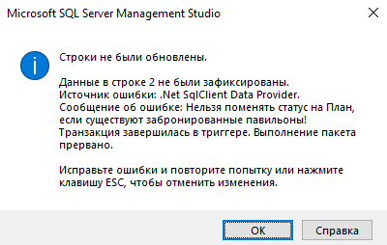
Код триггера
ALTER TRIGGER [dbo].[trigger_done]
ON [dbo].[SHOPING_CENTER]
FOR UPDATE AS
if exists(select * from inserted INNER JOIN
dbo.PAVILIONS ON dbo.PAVILIONS.id_shop_center = inserted.shop_center_id where
inserted.[status] = 'План' AND dbo.PAVILIONS.[status] = 'Забронирован'
OR dbo.PAVILIONS.[status] = 'Забронировано')
BEGIN

raiserror ('Нельзя поменять статус на План, если существуют забронированные павильоны! ',16,1)
rollback transaction

END;
1.8 ИНТЕРФЕЙС «МЕНЕДЖЕРА C»
АРЕНДА ПАВИЛЬОНА
Создайте хранимую процедуру, которая будет позволять арендовать или забронировать павильон в выбранном ТЦ.
Код процедуры
USE [PAVILIONS]
GO
SET ANSI_NULLS ON
GO
SET QUOTED_IDENTIFIER ON
GO
ALTER PROCEDURE [dbo].[NEW_RENT]
@rent_id int,
@renter_id int,
@shop_center_id int,
@id_employee int,
@pavilion_id nvarchar(10),
@rent_start date,
@rent_end date
AS
BEGIN
INSERT INTO dbo.RENTS VALUES(@rent_id, @renter_id, @shop_center_id, @id_employee, @pavilion_id, @rent_start, @rent_end);
IF EXISTS (SELECT * FROM Rents WHERE @rent_start > @rent_end) ROLLBACK TRANSACTION
IF EXISTS (SELECT * FROM Rents WHERE pavilion_id = @pavilion_id) ROLLBACK TRANSACTION
END;
Вызов процедуры
private void Next_Button_Click(object sender, RoutedEventArgs e)
{
string DateStartNew = DateStart.Text;
string DateEndNew = DateEnd.Text;
Pavilions pavilions = (Pavilions)PavilionsDataGrid.SelectedItem;
int Id_employees = 0;
string Sqlexpression = "SELECT MAX(rent_id) AS Expr1 FROM dbo.RENTS";
Manager.connection.Close();
Manager.connection.Open();
SqlCommand command = new SqlCommand(Sqlexpression, Manager.connection);
SqlDataReader reader = command.ExecuteReader();
if (reader.Read())
{
Rent_id = Convert.ToInt32(reader[0].ToString()) + 1;
}
reader.Close();
Manager.connection.Close();
Manager.connection.Open();
Sqlexpression = "SELECT id_employee, login FROM dbo.EMPLOYEES WHERE(login = @Login) ";
command = new SqlCommand(Sqlexpression, Manager.connection);
SqlParameter parameter = new SqlParameter("@Login", Login);
command.Parameters.Add(parameter);
reader = command.ExecuteReader();
if (reader.Read())
{
Id_employees = Convert.ToInt32(reader[0].ToString()) + 1;
}
reader.Close();
Manager.connection.Close();
Manager.connection.Open();
Sqlexpression = "NEW_RENT @rent_id = " + Rent_id + ", @renter_id = " + Convert.ToInt32(Renter_id) + ", " +
"@shop_center_id = " + Convert.ToInt32(Id_shop_center) + ", @id_employee = " + Id_employees + ", " +
"@pavilion_id = " + pavilions.id_pavilions + ", @rent_start = '" + DateStartNew + "', @rent_end = '" + DateEndNew + "'";
command = new SqlCommand(Sqlexpression, Manager.connection);
command.ExecuteReader();
Manager.connection.Close();
Manager.FrameMainWindows.Navigate(new ListTCPage(Login));
}

Ссылка на проект в хранилище на GitHub

https://github.com/Shura-mint213/Povilion.git

Выводы о полученных практических навыках

Я приобрел и отточил некоторые практические навыки, такие как импорт, работа с базой данных, создание триггеров и хранимых процедур, а также работа на языке C# и использование технологии ADO.NET для работы с базой данных.

